**BANK LOAN REPORT QUERY DOCUMENT**

1. **BANK LOAN REPORT | SUMMARY**SELECT * FROM bank_loan_data

**KPI’s:**

**Total Loan Applications**SELECT COUNT(id) AS Total_Loan_Applications FROM bank_loan_data  
  
  
**MTD Loan Applications**

SELECT COUNT(id) AS MTD_Total_Loan_Applications FROM bank_loan_data

WHERE MONTH(issue_date) = 12 and YEAR(issue_date) = 2021  
  
  
**PMTD Loan Applications**SELECT COUNT(id) AS PMTD_Total_Loan_Applications FROM bank_loan_data

WHERE MONTH(issue_date) = 11 and YEAR(issue_date) = 2021  


**Total Funded Amount**  
SELECT SUM(loan_amount) AS Total_Funded_Amount FROM bank_loan_data  
  
  
**MTD Total Funded Amount**SELECT SUM(loan_amount) AS MTD_Total_Funded_Amount FROM bank_loan_data

WHERE MONTH(issue_date) = 12 and YEAR(issue_date) = 2021  
  
  
**PMTD Total Funded Amount**  
SELECT SUM(loan_amount) AS MTD_Total_Funded_Amount FROM bank_loan_data

WHERE MONTH(issue_date) = 11 and YEAR(issue_date) = 2021  


**Total Amount Received**SELECT SUM(total_payment) AS Total_Amount_Received FROM bank_loan_data  
  
  
**MTD Total Amount Received**SELECT SUM(total_payment) AS MTD_Total_Amount_Received FROM bank_loan_data

WHERE MONTH(issue_date) = 12 and YEAR(issue_date) = 2021  
  
  
  
**PMTD Total Amount Received**SELECT SUM(total_payment) AS PMTD_Total_Amount_Received FROM bank_loan_data

WHERE MONTH(issue_date) = 11 and YEAR(issue_date) = 2021  


**Average Interest Rate**

SELECT AVG(int_rate)*100 AS Average_Interest_Rate FROM bank_loan_data

  
  
 **MTD Average Interest Rate**

SELECT AVG(int_rate)*100 AS MTD_Average_Interest_Rate FROM bank_loan_data

WHERE MONTH(issue_date) = 12 and YEAR(issue_date) = 2021  
  
**PMTD Average Interest Rate**

SELECT AVG(int_rate)*100 AS PMTD_Average_Interest_Rate FROM bank_loan_data

WHERE MONTH(issue_date) = 11 and YEAR(issue_date) = 2021  


**Average Debt to Income**SELECT AVG(dti)*100 AS Average_DTI FROM bank_loan_data  
  
**MTD Average Debt to Income**  
SELECT AVG(dti)*100 AS MTD_Average_DTI FROM bank_loan_data

WHERE MONTH(issue_date) = 12 and YEAR(issue_date) = 2021  
  
  
**PMTD Average Debt to Income**

SELECT AVG(dti)*100 AS PMTD_Average_DTI FROM bank_loan_data

WHERE MONTH(issue_date) = 11 and YEAR(issue_date) = 2021



**Good Loan Application Percentage**  
  
SELECT

(COUNT(CASE WHEN loan_status = 'Fully Paid' OR loan_status = 'Current' THEN id END) * 100.0) /

COUNT(id) AS Good_Loan_Percentage

FROM bank_loan_data  
  
  
**Good Loan Applications**  
SELECT COUNT(id) AS Good_Loan_Applications FROM bank_loan_data

WHERE loan_status = 'Fully Paid' OR loan_status = 'Current'  
  
  
**Good Loan Funded Amount**SELECT SUM(loan_amount) AS Good_Loan_Funded_Amount FROM bank_loan_data

WHERE loan_status = 'Fully Paid' OR loan_status = 'Current'  
  
  
**Good Loan Total Received Amount**SELECT SUM(total_payment) AS Good_Loan_Received_Amount FROM bank_loan_data

WHERE loan_status = 'Fully Paid' OR loan_status = 'Current'  


**Bad Loan Application Percentage**  
  
SELECT (COUNT(CASE WHEN loan_status = 'Charged Off' THEN id END) * 100.0)/ COUNT(id) AS Bad_Loan_Percentage FROM bank_loan_data  
  
  
**Bad Loan Applications**  
SELECT COUNT(id) AS Bad_Loan_Applications FROM bank_loan_data

WHERE loan_status = 'Charged Off'  
  
  
**Bad Loan Funded Amount**SELECT SUM(loan_amount) AS Bad_Loan_Funded_Amount FROM bank_loan_data

WHERE loan_status = ‘Charged Off’  
  
  
**Bad Loan Total Received Amount**SELECT SUM(total_payment) AS Bad_Loan_Received_Amount FROM bank_loan_data

WHERE loan_status = 'Charged Off'  


**Loan Status**

SELECT

loan_status,

COUNT(id) AS Total_Loan_Applications,

SUM(total_payment) AS Total_Amount_Received,

SUM(loan_amount) AS Total_Funded_Amount,

AVG(int_rate * 100) AS Interest_Rate,

AVG(dti * 100) AS DTI

FROM

bank_loan_data

GROUP BY

loan_status



SELECT

loan_status,

SUM(total_payment) AS MTD_Total_Amount_Received,

SUM(loan_amount) AS MTD_Total_Funded_Amount

FROM bank_loan_data

WHERE MONTH(issue_date) = 12

GROUP BY loan_status  
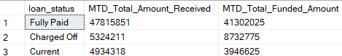

**B. BANK LOAN REPORT | OVERVIEW**  
  
**MONTH**

SELECT

MONTH(issue_date) AS Month_Number,

DATENAME(MONTH, issue_date) AS Month_Name,

COUNT(id) AS Total_Loan_Applications,

SUM(loan_amount) AS Total_Funded_Amount,

SUM(total_payment) AS Total_Received_Amount

FROM bank_loan_data

GROUP BY issue_date, DATENAME(MONTH, issue_date)

ORDER BY issue_date  
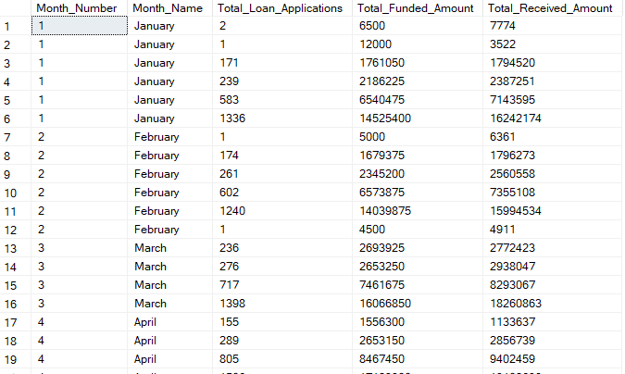  
  
**STATE**SELECT

address_state AS State,

COUNT(id) AS Total_Loan_Applications,

SUM(loan_amount) AS Total_Funded_Amount,

SUM(total_payment) AS Total_Amount_Receieved

FROM bank_loan_data

GROUP BY address_state

ORDER BY address_state  
  
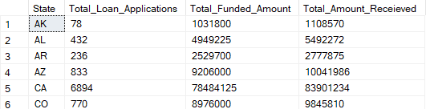  
  
**TERM LENGTH**SELECT

term AS Loan_Term_Length,

COUNT(id) AS Total_Loan_Applications,

SUM(loan_amount) AS Total_Funded_Amount,

SUM(total_payment) AS Total_Amount_Receieved

FROM bank_loan_data

GROUP BY term

ORDER BY term  
  
  
**EMPLOYEE LENGTH**SELECT

emp_length AS Employee_Length,

COUNT(id) AS Total_Loan_Applications,

SUM(loan_amount) AS Total_Funded_Amount,

SUM(total_payment) AS Total_Amount_Received

FROM bank_loan_data

GROUP BY emp_length

ORDER BY emp_length  
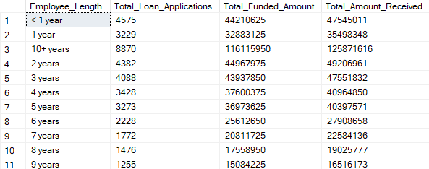

**Loan Purpose Breakdown**SELECT

purpose AS Purpose,

COUNT(id) AS Total_Loan_Applications,

SUM(loan_amount) AS Total_Funded_Amount,

SUM(total_payment) AS Total_Amount_Received

FROM bank_loan_data

GROUP BY purpose

ORDER BY purpose 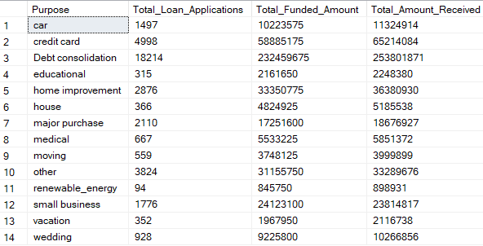

**HOME OWNERSHIP**SELECT

home_ownership AS Home_Ownership,

COUNT(id) AS Total_Loan_Applications,

SUM(loan_amount) AS Total_Funded_Amount,

SUM(total_payment) AS Total_Amount_Received

FROM bank_loan_data

GROUP BY Home_Ownership

ORDER BY Home_Ownership  
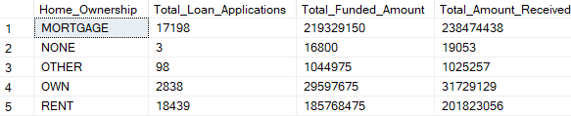  
  
**FILTERS**SELECT

home_ownership AS Home_Ownership,

COUNT(id) AS Total_Loan_Applications,

SUM(loan_amount) AS Total_Funded_Amount,

SUM(total_payment) AS Total_Amount_Received

FROM bank_loan_data

WHERE grade = 'A' and address_state = 'CA'

GROUP BY Home_Ownership

ORDER BY COUNT(id) DESC  
  
